B Grade Chess grid example

Source: <https://stackoverflow.com/questions/21432435/chess-board-coordinates>

What I was looking for: An example and helpful way for us to understand the coordinate grid of a chess board.

What I learned: What I learned from the example was first the variables he created two of them.

Rank= 8 from what I understand is the amount columns and rows meaning 1,2,3,4,5,6,7,8 would be the regular x and y coordinates but if you used the traditional chess grid it would be A,B,C,D,E,F,G,H.

Files I can assume are the numbers on the sides of the grid meaning how if you say move a rook to g8, g is the Rank and 8 is the File it goes the column first than the row. That’s why we say rook to g8.

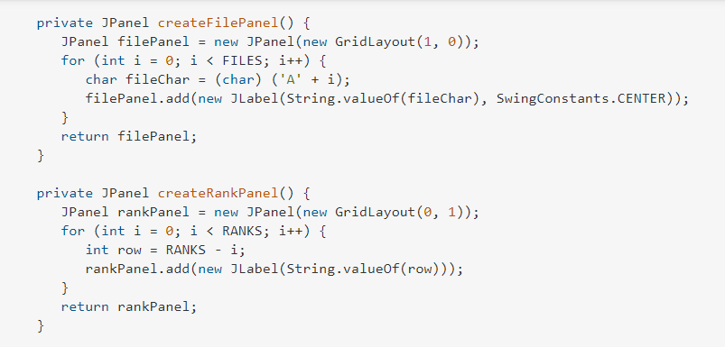

Above is the code the person used to align the columns and rows to the sides of the board and to the top and bottom.